SOLUTIONS FOR AQUATIC BIODIVERSITY & SUSTAINABLE AGRICULTURE

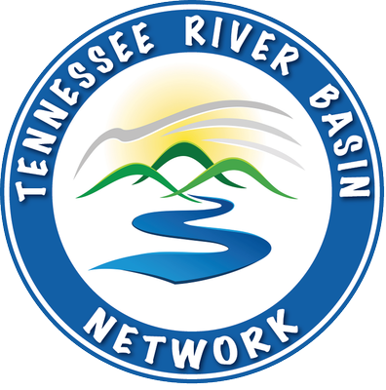

A TENNESSEE RIVER BASIN NETWORK TRAINING EVENT

Date: March 15th, 2021
Time: 1:00pm – 3:00pm CST
Location: TN NRCS Area 1 - Virtual
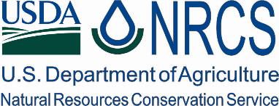
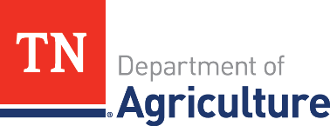
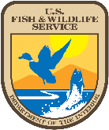
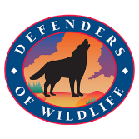
Time | Topic
1:00 PM | Welcome
1:10 PM | Introductions
1:20 PM | Unique Species and Habitats of Area 1
1:35 PM | Threats & Stressors
1:55 PM | Technical Resources and Effective Action
2:15 PM | Landowner Communication
2:30 PM | Partnership
2:50 PM | Meeting Close
3:00 PM | Adjournment

